**Q1. Which two operator overloading methods can you use in your classes to support iteration?**

**Ans: __iter__ and __next__ are the operator overloading methods in python that support iteration and are collectively called iterator protocol.**

* **__iter__ returns the iterator object and is called at the start of loop inour respective class.**
* **__next__ is called at each loop increment , it returns the incremented value. Also stop iteration is no value to return.**

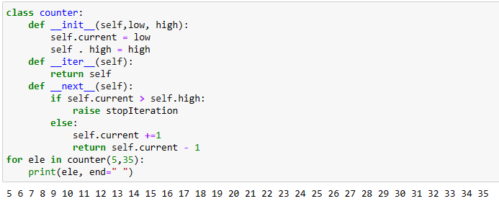

**Q2. In what contexts do the two operator overloading methods manage printing?**

Ans: __str__ and __repr__ are two operator overloading methods that manage printing .

* The difference between both of these operator is : The goal of __repr__ is to be unambiguous and __str__ is to be readable.
* Whenever we are printing any object reference internally , __str__ method will be called by default.
* The main purpose of __str__is for readability . it prints the informal string representation of an object . it may not be possible to convert result string to original object.
* __repr__ is used to print official string representation of an object , so it includes all information and development.

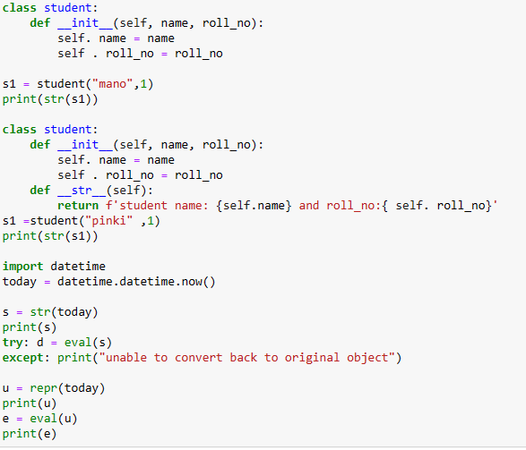

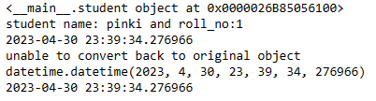

**Q3. In a class, how do you intercept slice operations?**

**Ans**: in a class use of **slice( )** , **__getitem__** method is used for intercept slice operation . This slice method is provided with start integer, stop integer number and step integer number.

Example:

**__getitem__(slice(start, stop, step))**

**Q4. In a class, how do you capture in-place addition?**

Ans: **a+b** is normal addition .whereas **a+=b** is inplace addition operation . in this in-place addition **a** itself will store the value of addition . in a class **__iadd__** method is used for this in-place operation

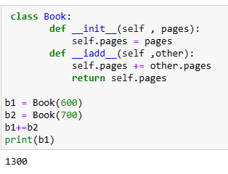

**Q5. When is it appropriate to use operator overloading?**

**Ans**: operator overloading is used when we want to use an operator other than its normal operation to have different meaning according to the context required in user defined function.

